# User Requirements:

**{User Requirement 1}: When entering text on mobile devices, user should not make more typos (slips) when operating with one hand compared to operating with both hands (U05-07, U5-08, U05-13, U05-23, U05-27, U05-29, U05-35, U01-14, U01-15, U03-04).**

**(jerry, isaac, franklin,)**

**User Requirement 2 : User should not need to manually fix any mistakes produced by the system’s keyboard assistive features (e.g., autocorrect) when entering text on their mobile device with one hand**

**(Jerry, LISTS OF POSSIBLE WORDS**

**{User Requirement 3}: User should be able to fix a typo (mistakenly-spelled word) using one hand independently of keyboard assistive features and without accidentally modifying any other (correctly-spelled) characters or words**

**(Jerry, SLIDE TO DELETE WORD**

**4: User should be able to locate and enter emojis, punctuations, and numerics on the mobile device with one hand more efficiently (faster) than their default (i.e., current or existing) method of entry**

**(Jerry, franklin, Yichen)**

**5: Users should be able to navigate, communicate and interact with different keyboard elements accurately (without slips) using one hand without straining (overextending) their thumb (hand) or repositioning the mobile device**

**(Jerry, Yichen, Daniel, Franklin)**

**Jerry’s adjustable shifted keyboard with a few main punctuation on the main keyboard**

**6: Users should be able to hold their mobile device one-handed in a secure manner without inflicting physical discomfort**

**(Daniel, Jerry**

# Instructions:

* Each person
  + write 1 or 2 sentences for the feature description (for your own features)
  + copy paste your sketches & storyboard corresponding to the features
  + and finally, write critiques for 2 other person’s features
    - if you see if the feature has already been critiqued by 2 people, don’t write it for that, pick for someone else
    - **(Critiques are not necessarily cons but how can we improve it, DO NOT MAKE IT SOUND NEGATIVE)**
    - **Critiques also need to talk about what is good about the idea**

# Franklin’s Features

**Perspective keyboard:**

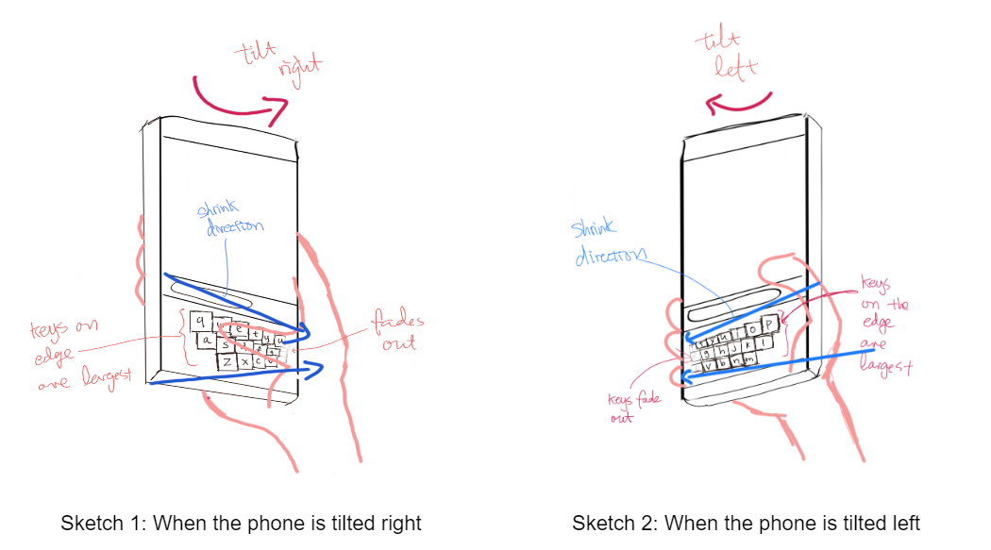

Similar to the perspective zooming feature on the iPhone's wallpaper, when the user tilts their phone during text entry on their virtual keyboard, the keys would shift left and right and enlarge and/or shrink based on the user’s tilting action. The more intelligible description is that the keyboard in the phone “virtually” tilts according to the user, and keys slide towards the thumb, as per sketch 1 so that the edge keys are easier to reach. My persona (Thomas) is right-handed, so tilting right (sketch 2) does not help as much, but if the user were to be left handed, this would be helpful.

Note that this feature is delegating movement to the wrist and alleviating the thumb. The hand should still have a steady clutch on the phone. It is only the wrist that is moving while the tilting happens.

There should also exist a deadzone where if the phone is somewhere near leveled, the tilting effect should not happen or is drastically toned down. The option to configure these should be available.

Critiques:

* Isaac: Unintentional tilting. For instance, if the user is walking, there will be a small amount of tilting, which can cause the keys to shift as well.
* Isaac: Difficult to type fast since the position of the keys will always be changing. So the user can’t use their muscle memory to memorize where each key is. Depending on the tilting angle, keys will be in different positions, so the user has to find the specific keys.
* Jerry: The design definitely helps to address the User Requirement 4, as the user will be able to comfortably reach the keys on the left edge and on the right edge of the keyboard without repositioning their hand, and 6, since they are now able to securely hold their phone.

**Moving functional keys to top corners:**

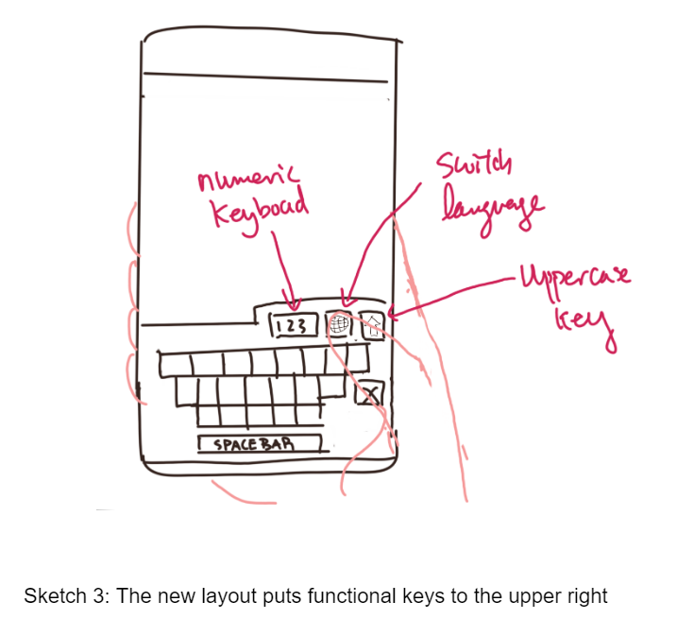

The newly designed keyboard layout places more functional keys like the numeric keyboard, keyboard switch, and uppercase key to the upper right corner of the keyboard. This is a very natural location where Thomas would place his thumb, without having to shift the phone in his hand too much and compromising the hand’s hold on the phone. Placing these keys too low would induce the thumb to move down towards the palm, and the palm would open up, losing surface contact with the back of the phone.

Critiques:

* Isaac: If you place too many functional keys on top, it will become very cluttered. Maybe the user can have an option to customize that area of the screen.
* Jerry: This design definitely helps to address User Requirement 4, as it allows the user to comfortably reach the numeric-keyboard-switch key, language-switch key, and uppercase key, and it also helps to address some of User Requirement 5, since it allows easy switching between keyboards. However, I think the user might still struggle a bit with entering let’s punctuations/numbers/emojis because after all, they still have to switch to a different keyboard to enter those non-alphabetical characters, and then switch back the keyboard. I think we can try to find a way to allow users to enter frequently-used non-alphabetical characters without even switching the keyboard at all.

# 

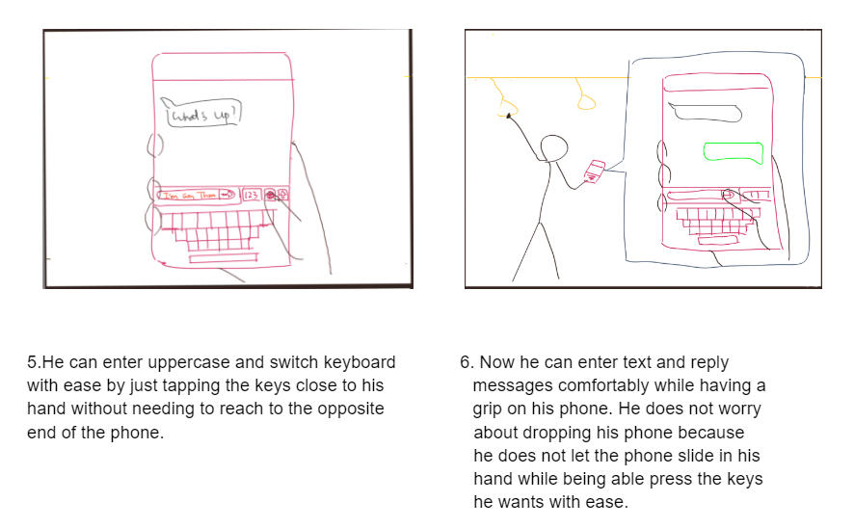

# Daniel’s Features

1. Mini Mousepad
   1. A transparent, square region near the dominant side of the phone. When activated, the mousepad will show a transparent circle to indicate a cursor which is controlled by the thumb motion. To select, the user needs to double tap any part of the box region. Once finished, the user can minimize it by tapping the arrow button.

Critiques:

* Isaac: The mini mousepad might be too small so it would be difficult to accurately select UI elements. Also the thumb is not as dexterous as other fingers such as the index finger, so it might be even harder to accurately manipulate the cursor.
* Franklin: An intuitive idea for navigating UI elements. However, depending on the position and size of the activation region as well as what widget this activation region exists in, it is possible to easily accidentally activate this if this “box” always persists on screen.

1. Rotating Keyboard
   1. The rotating keyboard will allow users to shift the keyboard horizontally. There is a scrollbar near the bottom of the keyboard to prevent users from over rotating the keyboard. However, to rotate, the user can swipe anywhere on the keyboard.

Critiques:

* Isaac: Accidentally rotation. For instance, if the user wants to press a key but then his fingers accidentally slides, the keyboard might rotate. Also, there should be a quick access button that automatically resets the keyboard to its default layout.
* Franklin: A solution for reaching edge keys. However, this can introduce extra steps of sliding back and forth with the thumb to input a single, which can make text entry a bit tedious. The user would have to lift their finger from a key to touch a scroll bar at the bottom between key inputs

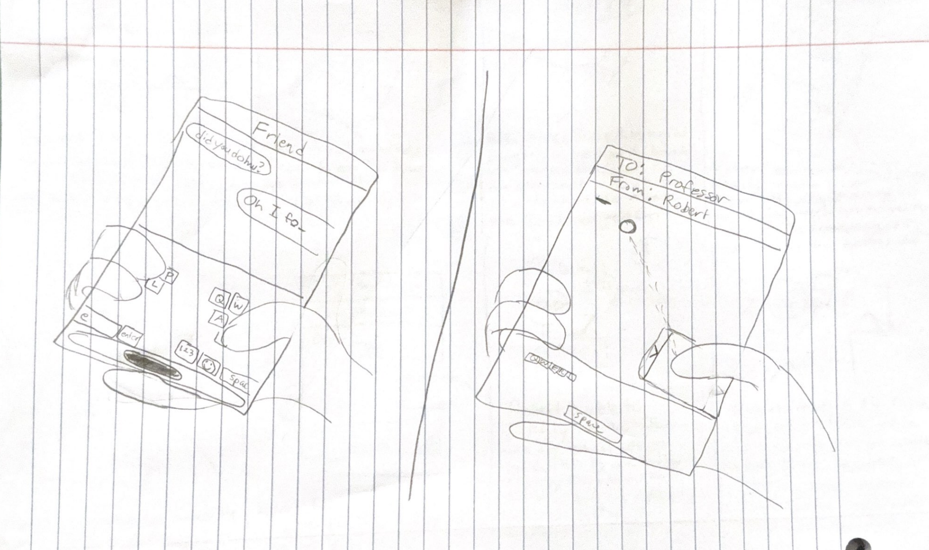

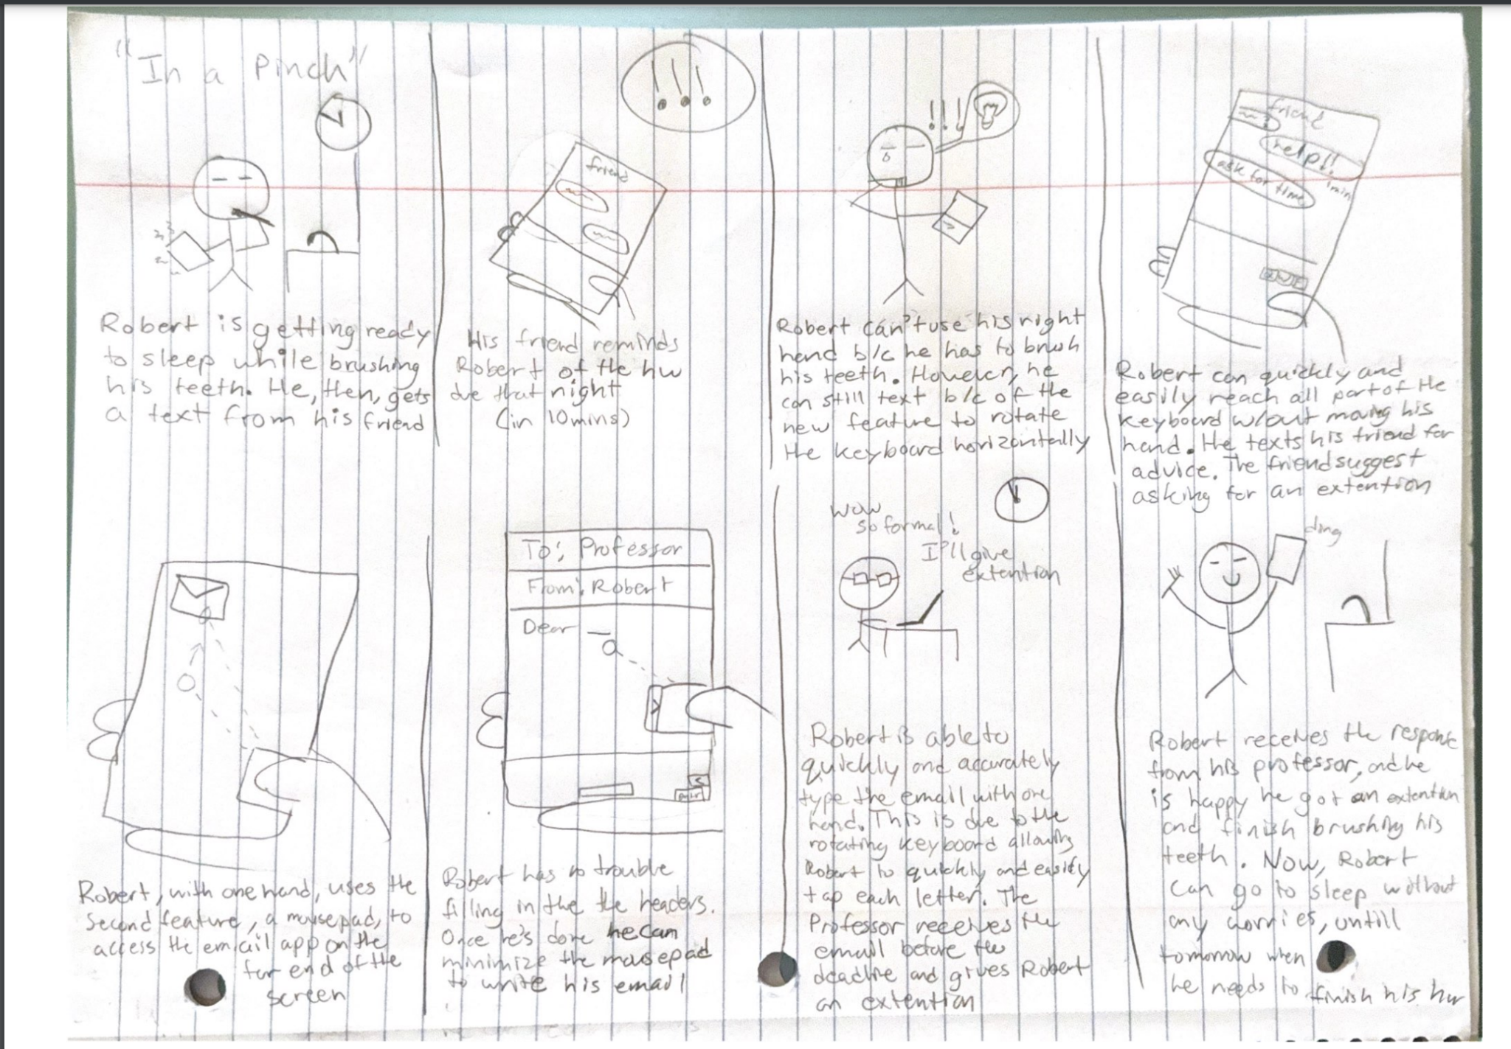

# Jerry’s Features

1. **Switching to one-handed keyboard**

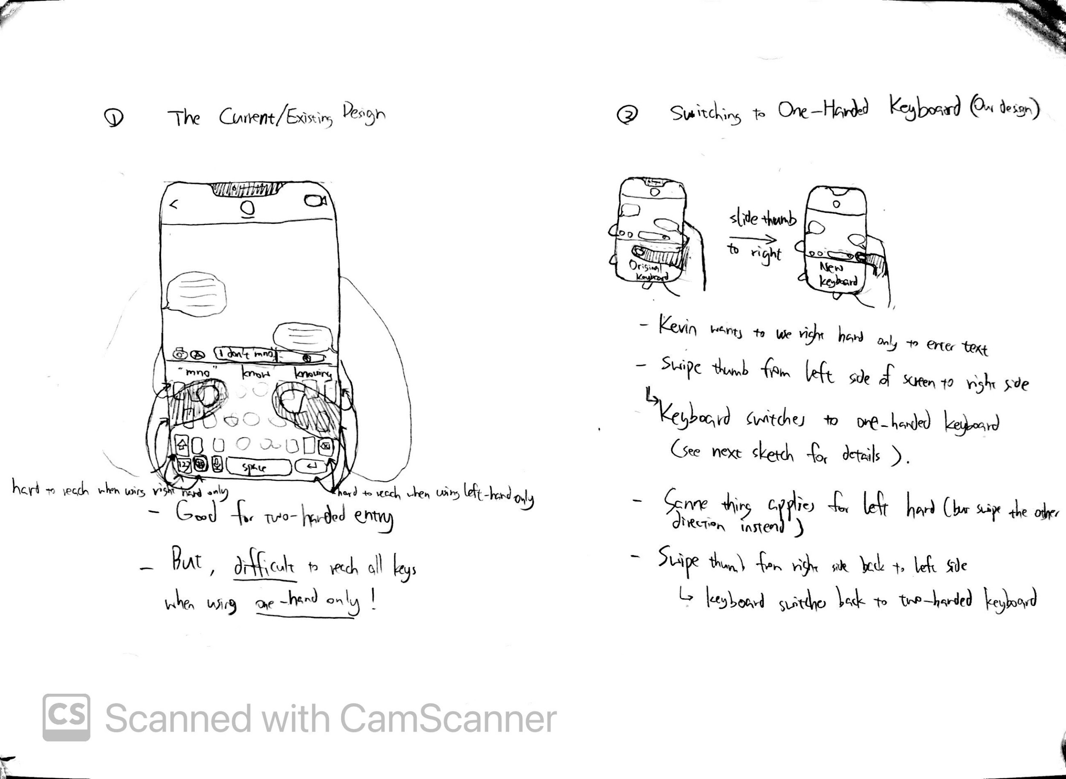Allows the user to easily switch between two-handed keyboard and one-handed keyboard, by sliding the thumb from left to right (note the keyboard currently designed for right-handed users).

Critiques:

* Daniel: This feature may interfere with the swipe-to-text feature
* Yichen: This feature indeed satisfies the requirements for left-handed users, as well as switching between one-handed keyboard and two-handed keyboard. I like the novel design idea. However, some app might have preset functionality for sliding the thumb from left to right, this might need to mistouch. For example, in the Instgram home page, when you slide the thumb from left to right, it might go to the “post a new story” page rather than switching keyboards.

1. **Shifted keyboard**

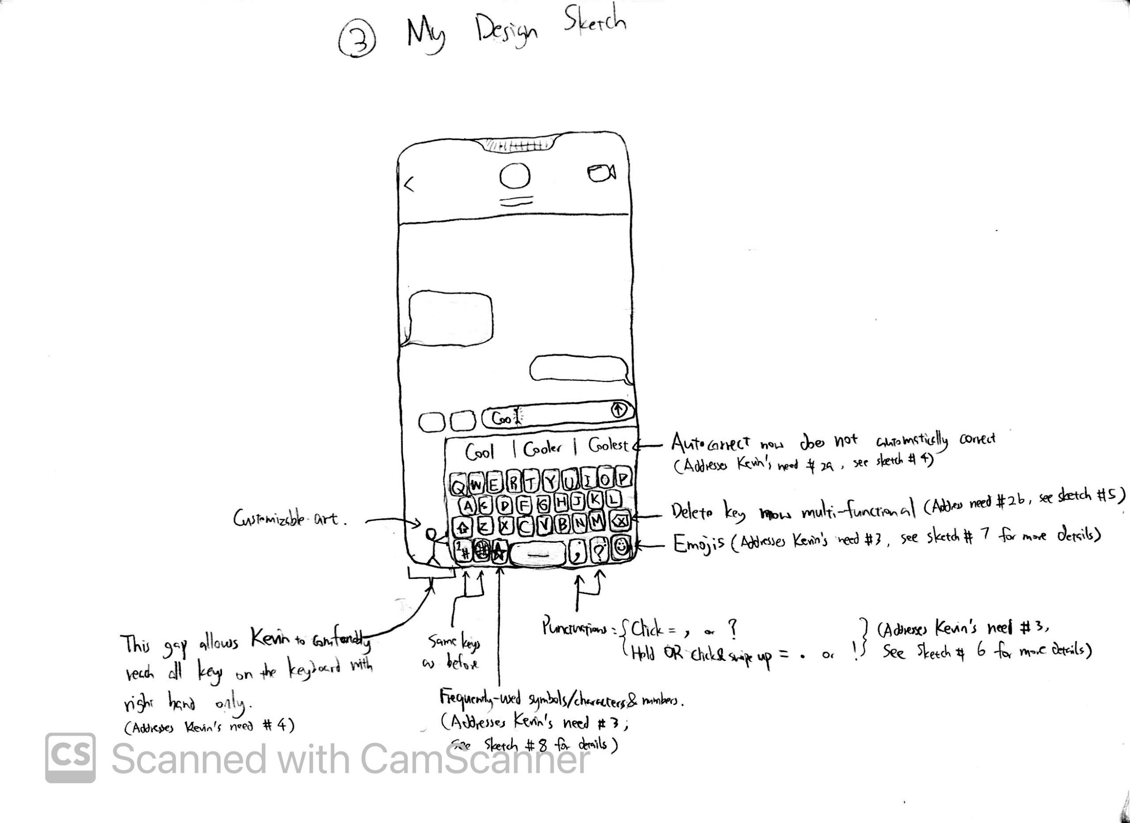

The new keyboard is now shifted to the right, allowing user to easily reach all keys on the keyboard. This addresses User Requirements 5 and 6.

Critiques:

* Daniel: Could also add a way to adjust how far the user wants the keyboard to be shifted
* Yichen: I like the design idea, it can allow users to easily reach all keys on the keyboard without scratching the finger. This can reduce the fatigue to the user. However, this ‘shrink’ keyboard might have smaller key size than usual, users might come across more mistouch and misspelled words.

1. **Improved Autocorrect**

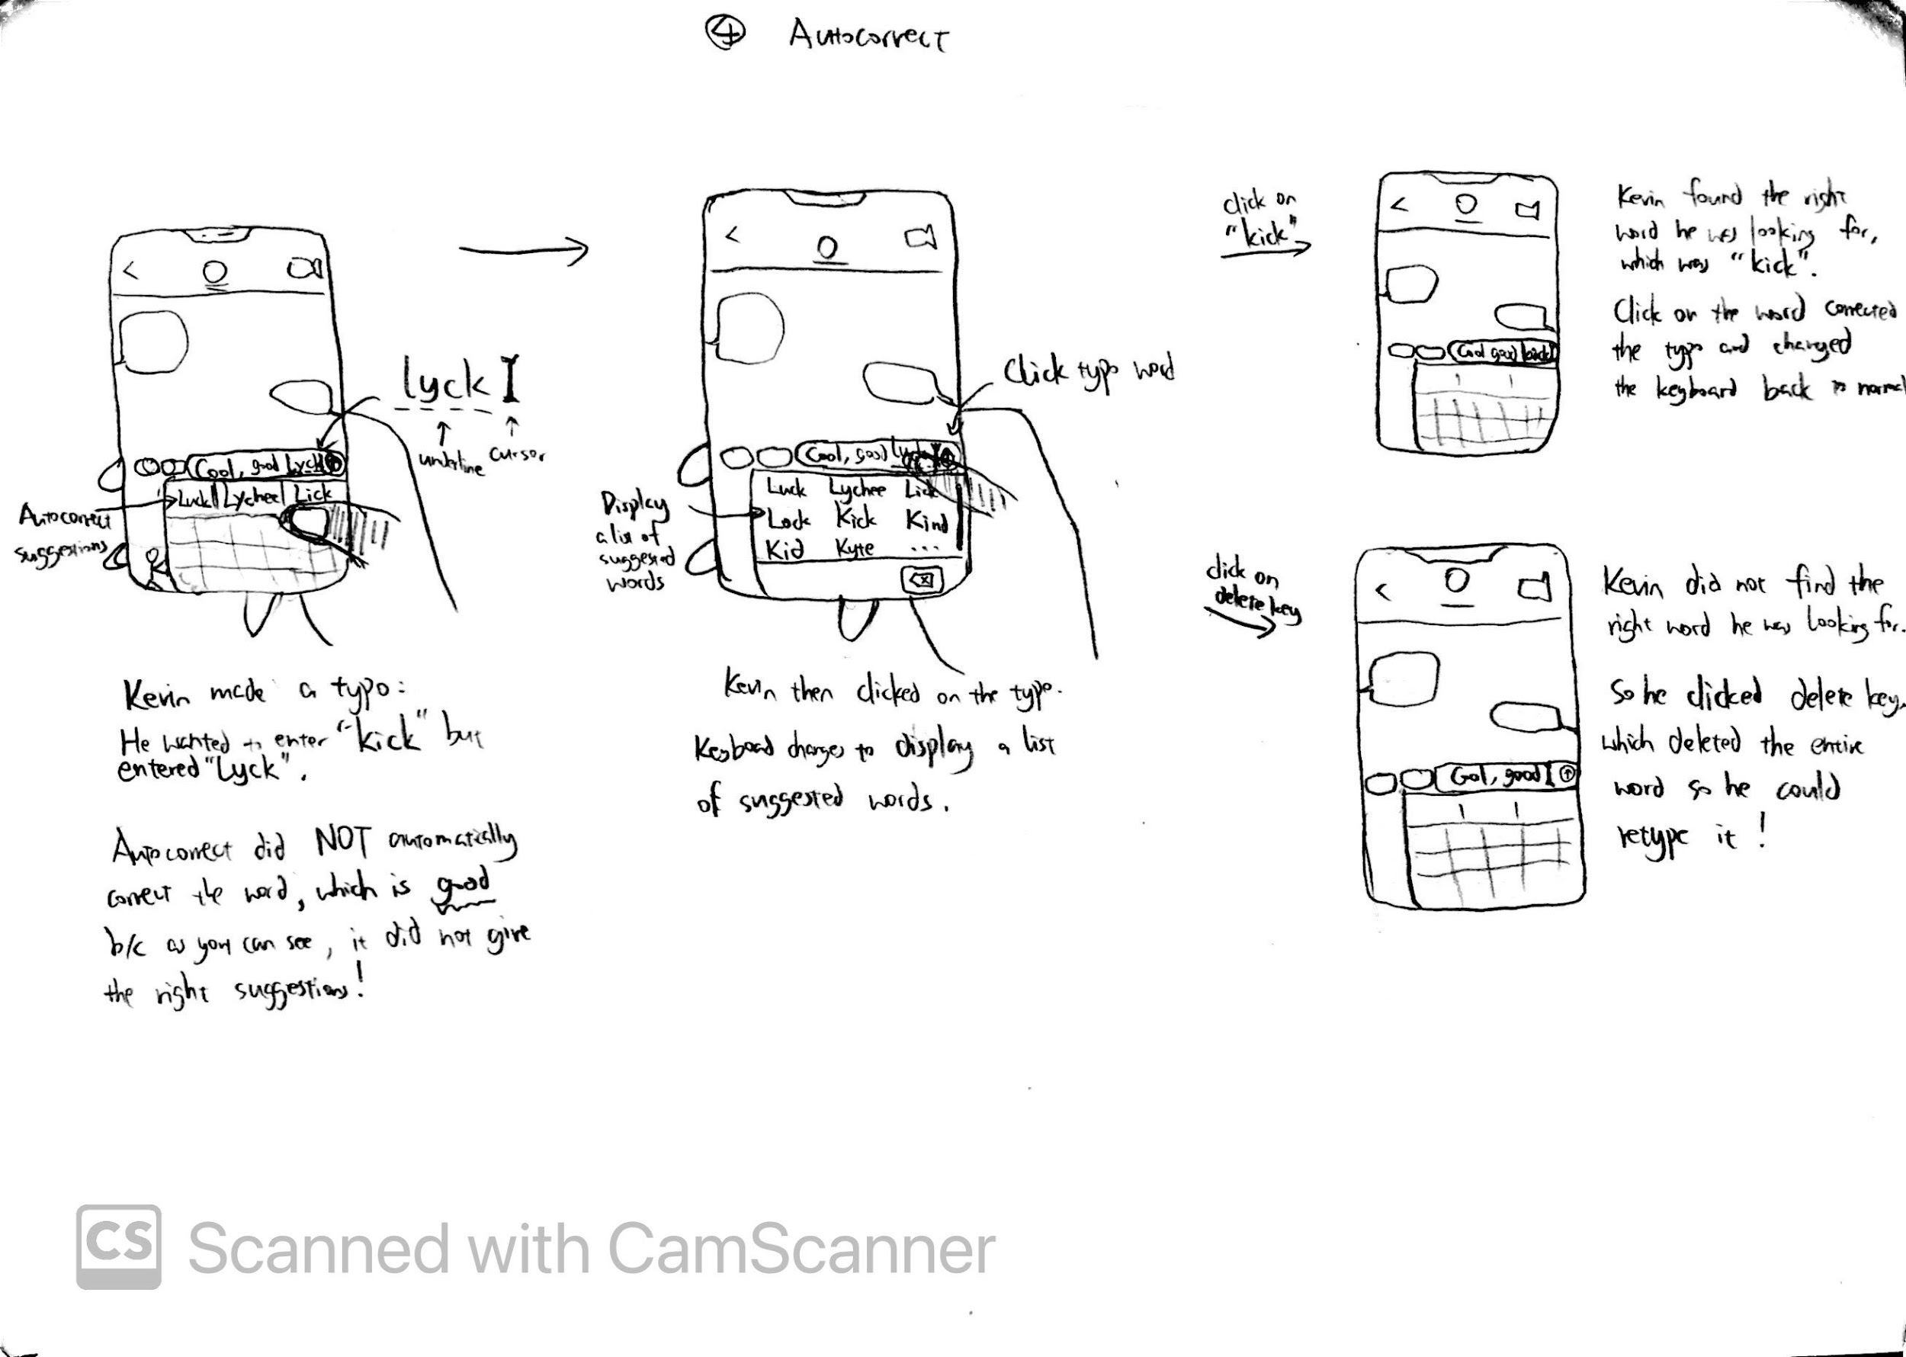Autocorrect can sometimes be counterproductive [User Requirement 2]. To prevent this, autocorrect no longer automatically changes the typo; it only underlines the typo and the user can choose to manually change it or not. If the user would like to change the typo, he simply clicks on the word and autocorrect will display a list of 9 words on the keyboard for him to select from; he can also scroll down the list of words to see more suggestions. If he finds the right word, he simply clicks on the word and Autocorrect will replace the typo with the word clicked. If cannot easily find the right word, he simply clicks on the “delete” key which deletes the entire typo, and he can then just retype it.

Critiques

* Daniel: I like how they provide more than one correction. Can probably order words from most likely to least likely based on user’s habit
* Franklin: Isn’t this an existing solution if you turn off autocorrect? Otherwise it is a very feasible alternative to autocorrect.
* Yichen: I liked the idea, it improves the current autocorrect feature. For further improvement, how about combining Issac’s idea to use ML features to show the ‘most possible’ word at the first place.

1. **Improved Delete Key**

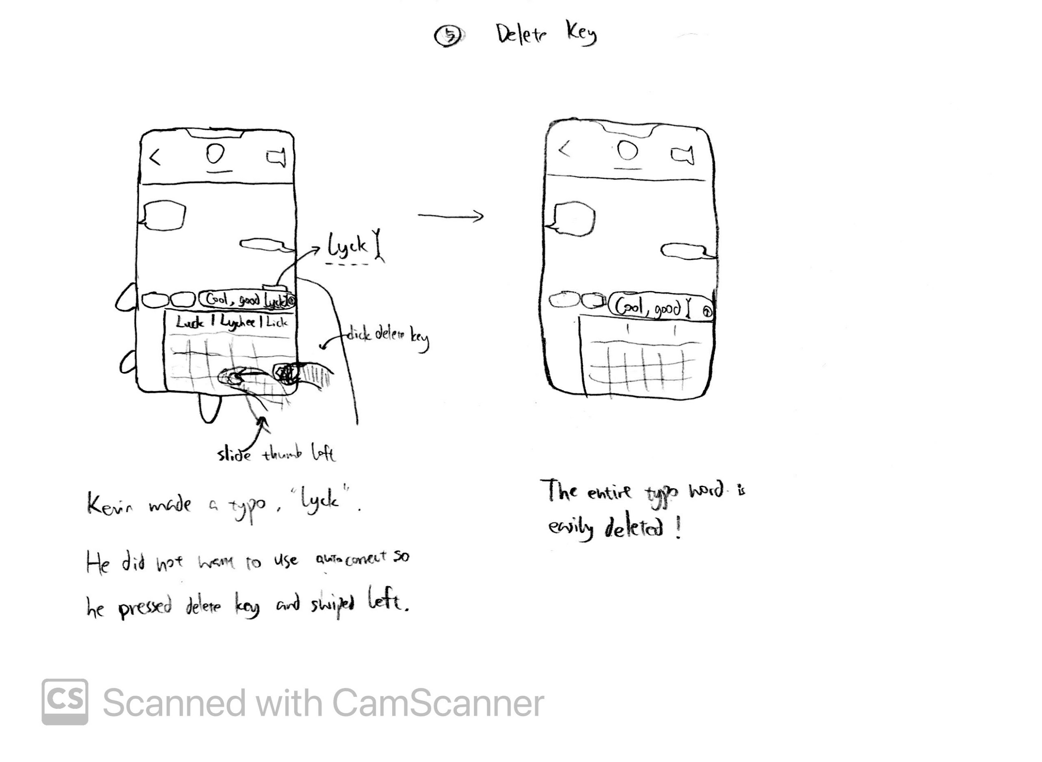

Delete can be counterproductive, such as accidentally deleting words not part of the typo [User Requirement 3]. The “delete” key keeps the original functionalities, but also includes a new functionality: Pressing the delete key followed by sliding left will delete an entire word. This allows the user to quickly and accurately delete the typo itself and nothing else.

Critiques

* Franklin: If the user wants to delete multiple words in a row, does the user hold down their finger after the swipe? Or is it not allowed to do so? As long as the user has the need to hold down the finger to multi-delete, there will be accidental deletes of entire words.
* Yichen: This design really expands the functionality of the current delete button, which might be useful in typing. But when user slides left to delete the entire word, he might mistouch some keys. My suggestion is to let the user long press(or double click) and then slide left the key to avoid mistouching.

1. **Punctuation keys**



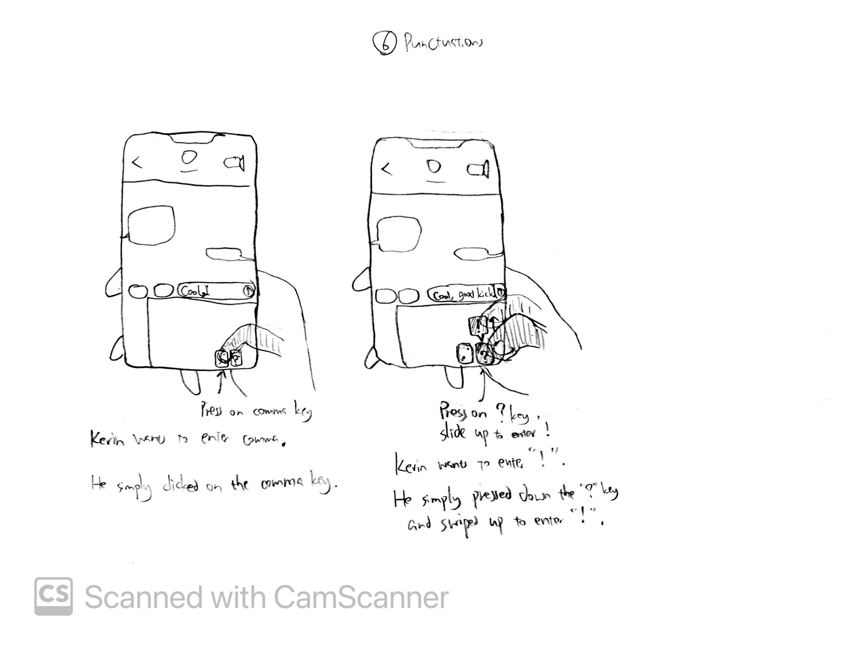

User should easily enter punctuations [User Requirement 5]. The new punctuations key at the bottom right corner allows the user to conveniently enter four frequently-used punctuation marks with just one step, which is pressing on the corresponding punctuation key, eliminating the excessive steps of keyboard switching.

Critiques:

* The design is great. It expands the feature of punctuation. However, a user who familiar with the original punctuation keyboard might be not get accustomed at the first time. So maybe clarify that user can choice either the original punctuation keyboard or the improved punctuation keyboard on the setting.

1. **Emojis Key**

User should easily enter emojis [User Requirement 5]. The emojis key at the bottom right corner allows the user to conveniently enter any emojis. Clicking this key displays a list of frequently-used emojis at the top of the keyboard (replacing the suggested words of autocorrect), which the user can easily click on to enter them. If the user wants to enter some emoji not in the list, he can easily search for the emoji by typing the words that describe this desired emoji using the letters keyboard below (without doing any switching), and the list will be updated to reflect the search.

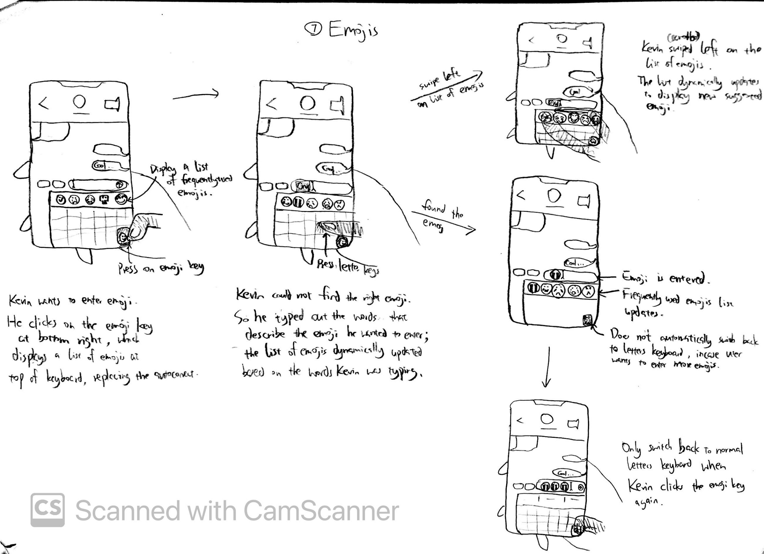

Critiques:

* Daniel: This design may cause issues when a right handed individual needs to use their left hand to text from time to time

1. **Special Characters Key**

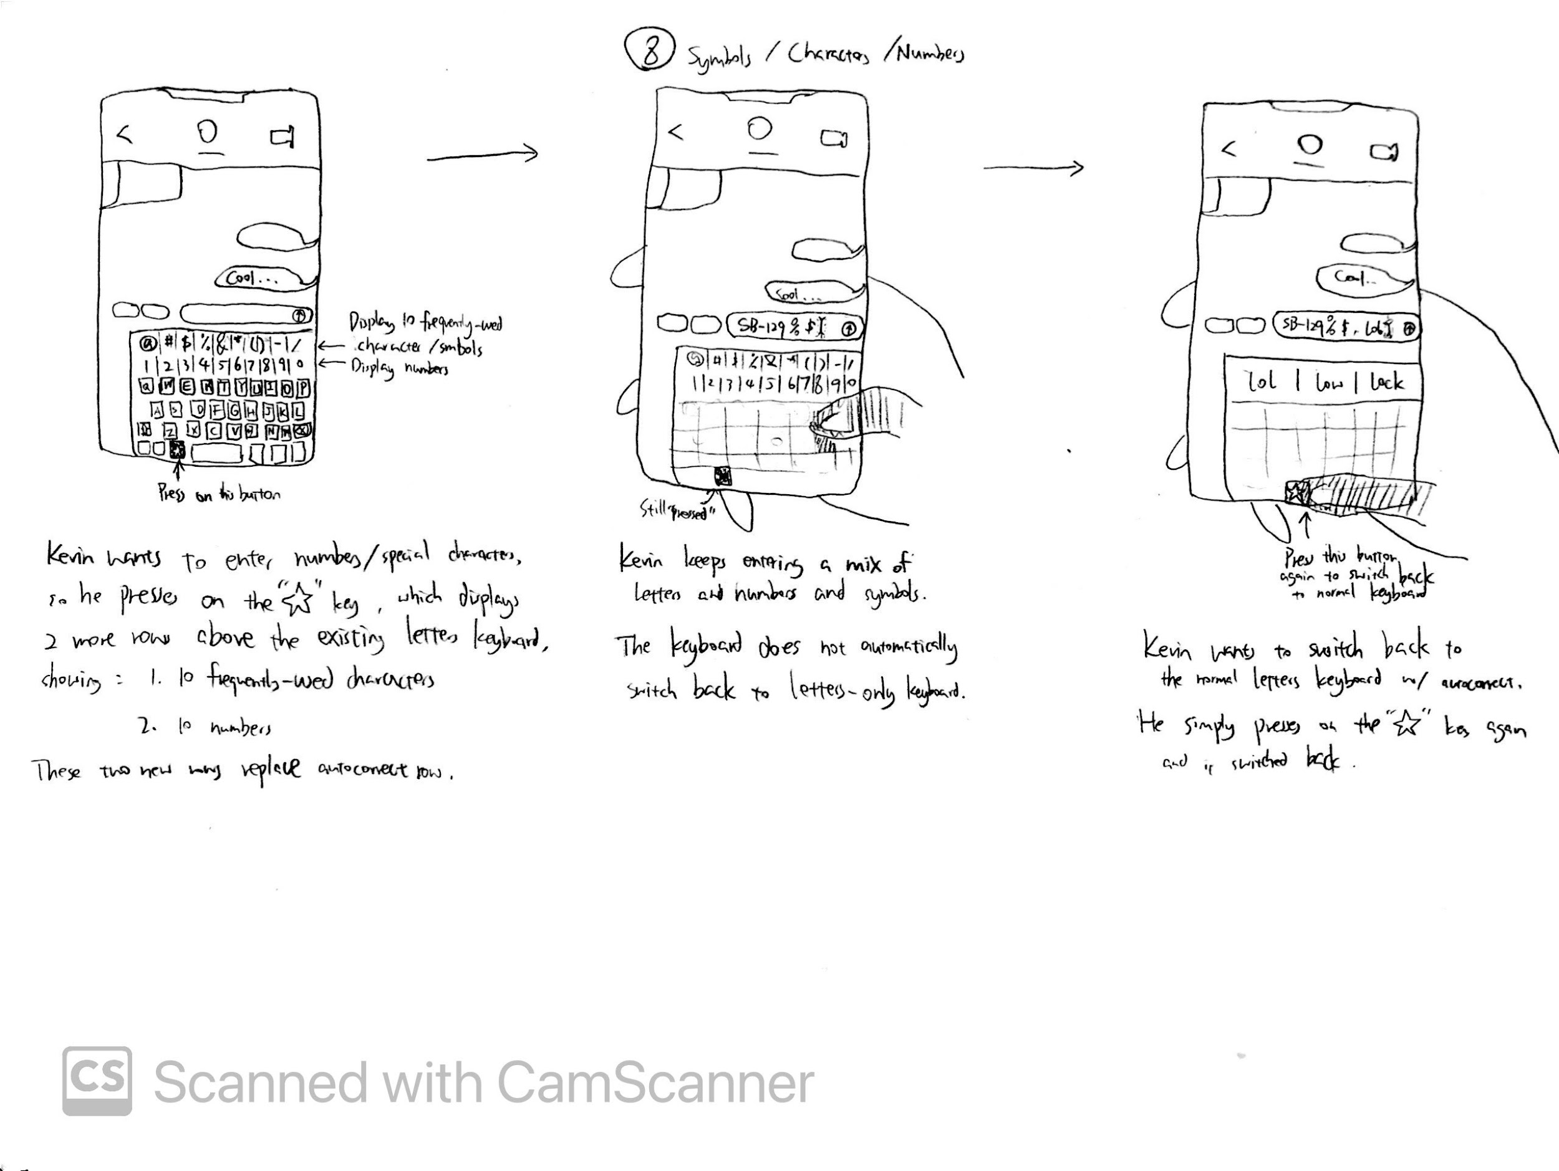

User should easily enter some special characters [User Requirement 5]. Clicking the“star” key at the bottom row displays both the numbers and 10 frequently used characters at the top of the keyboard (replacing the suggested words from autocorrect) serving as an extension to the existing keyboard. This allows the user to easily enter any combination of letters, numbers, and special characters without switching keyboards back and forth.

**Storyboards**

Storyboard 1: Showing features 1, 2

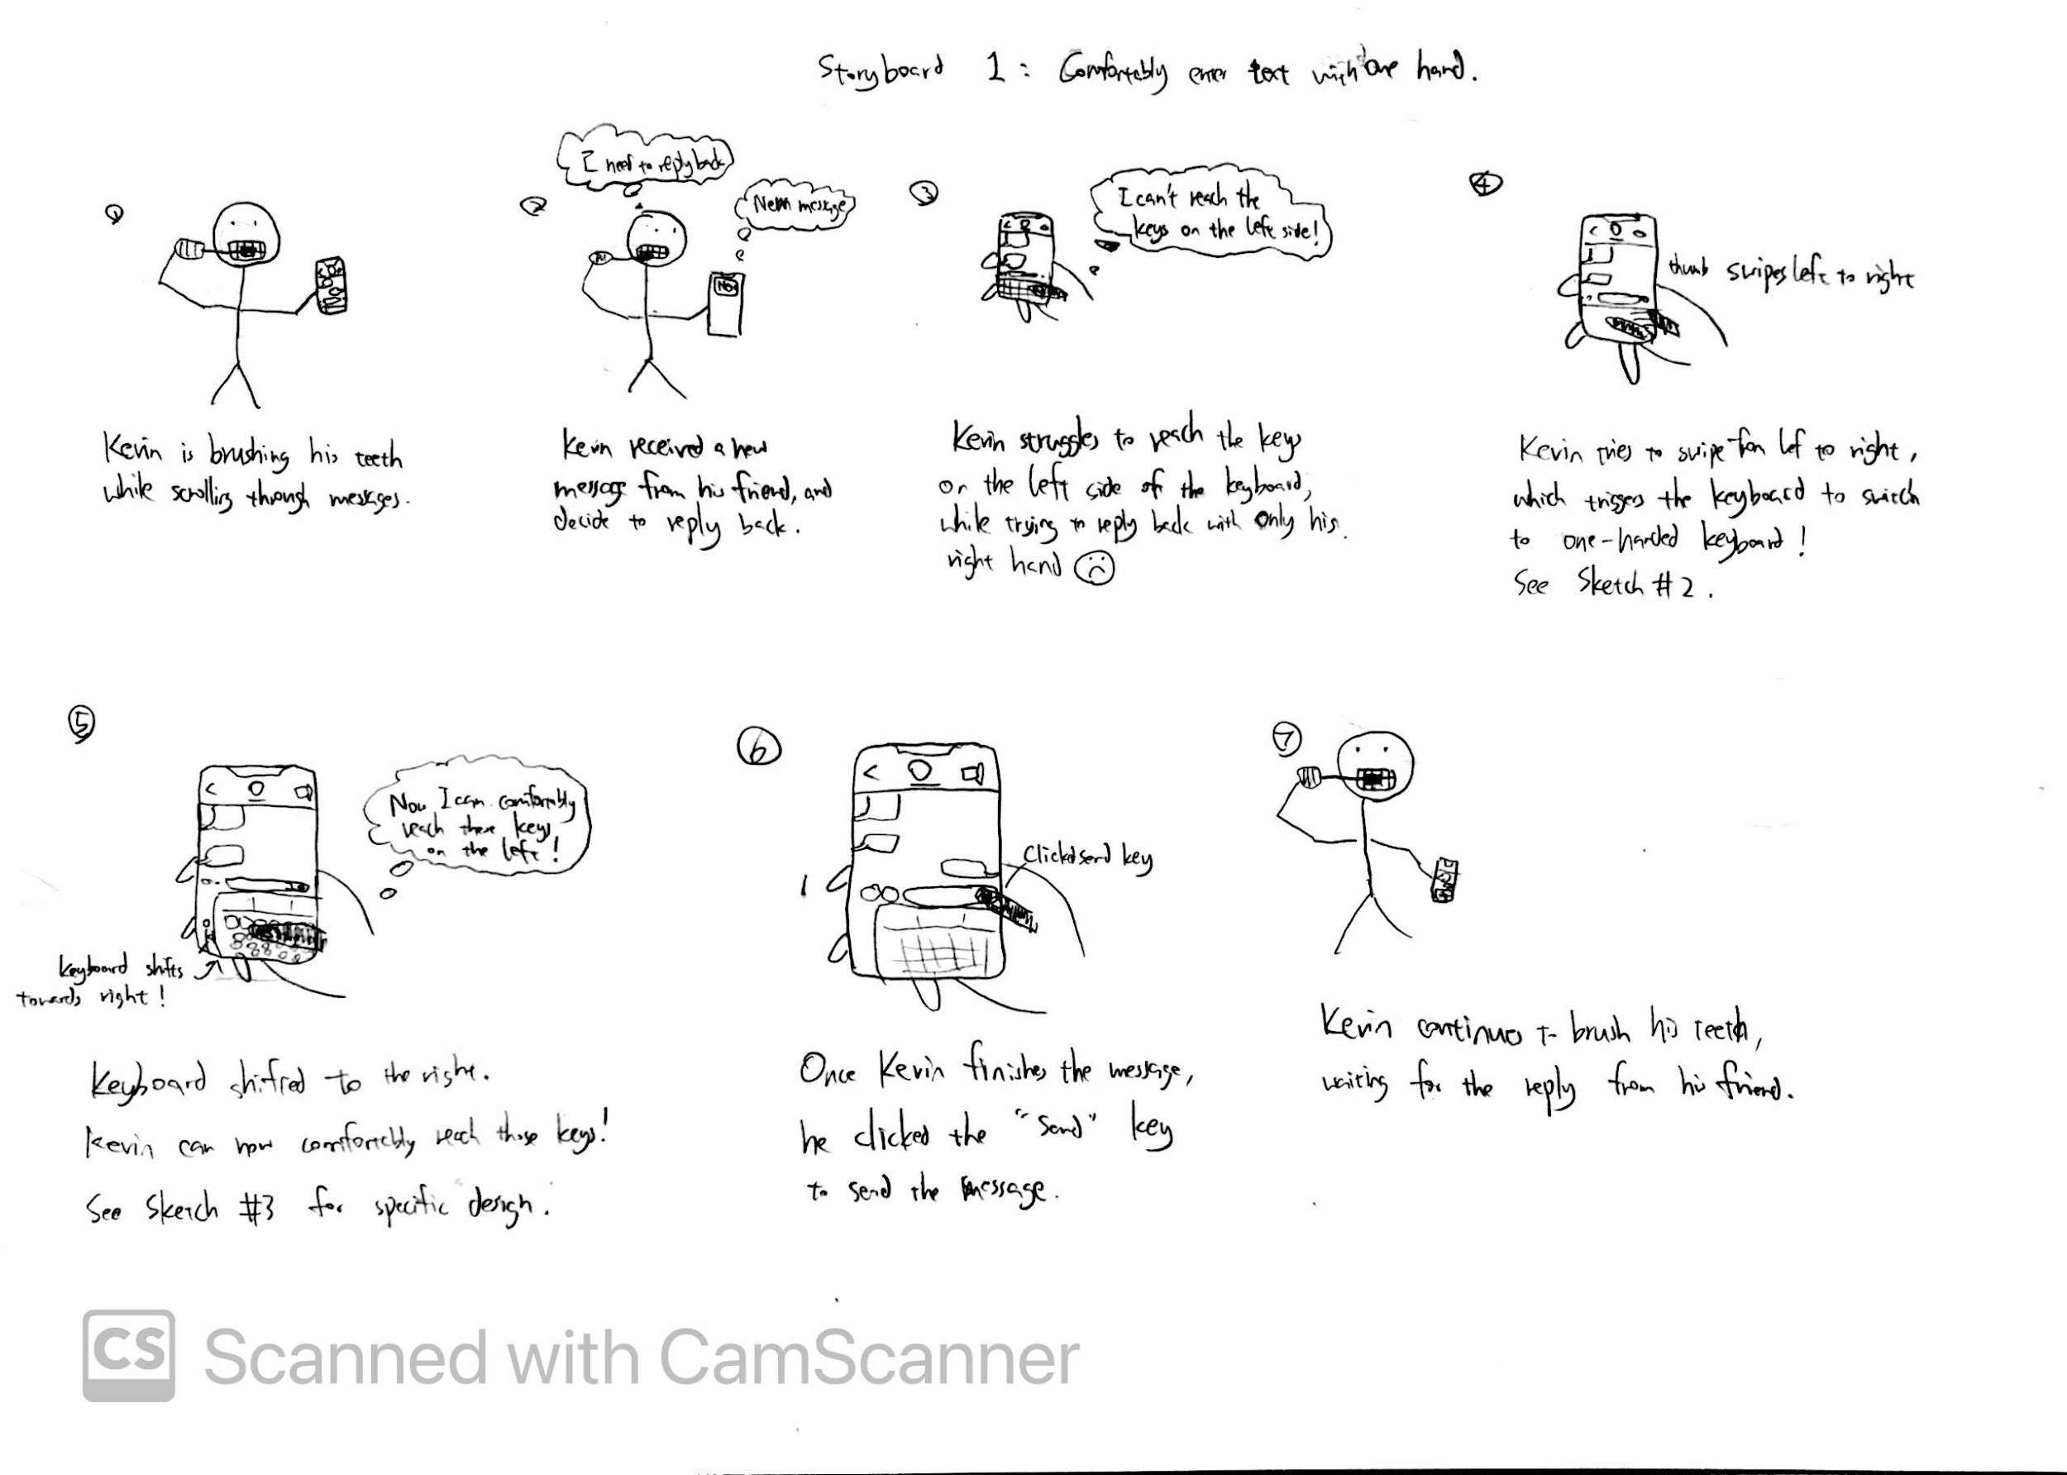

Storyboard 2: Showing features 3, 4

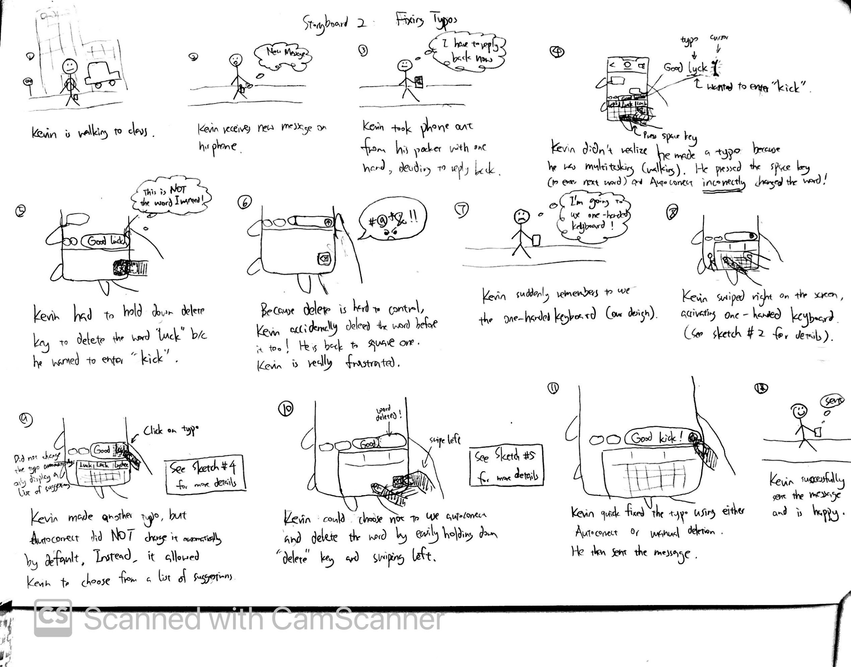

Storyboard 3: showing features 5, 6

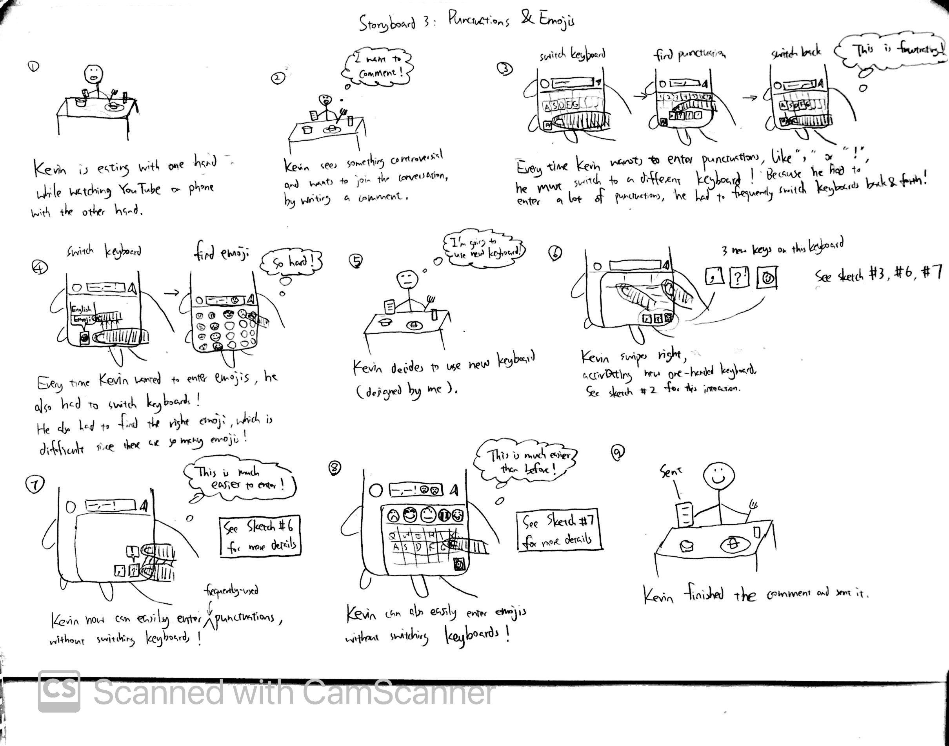

Storyboard 4: showing feature 7

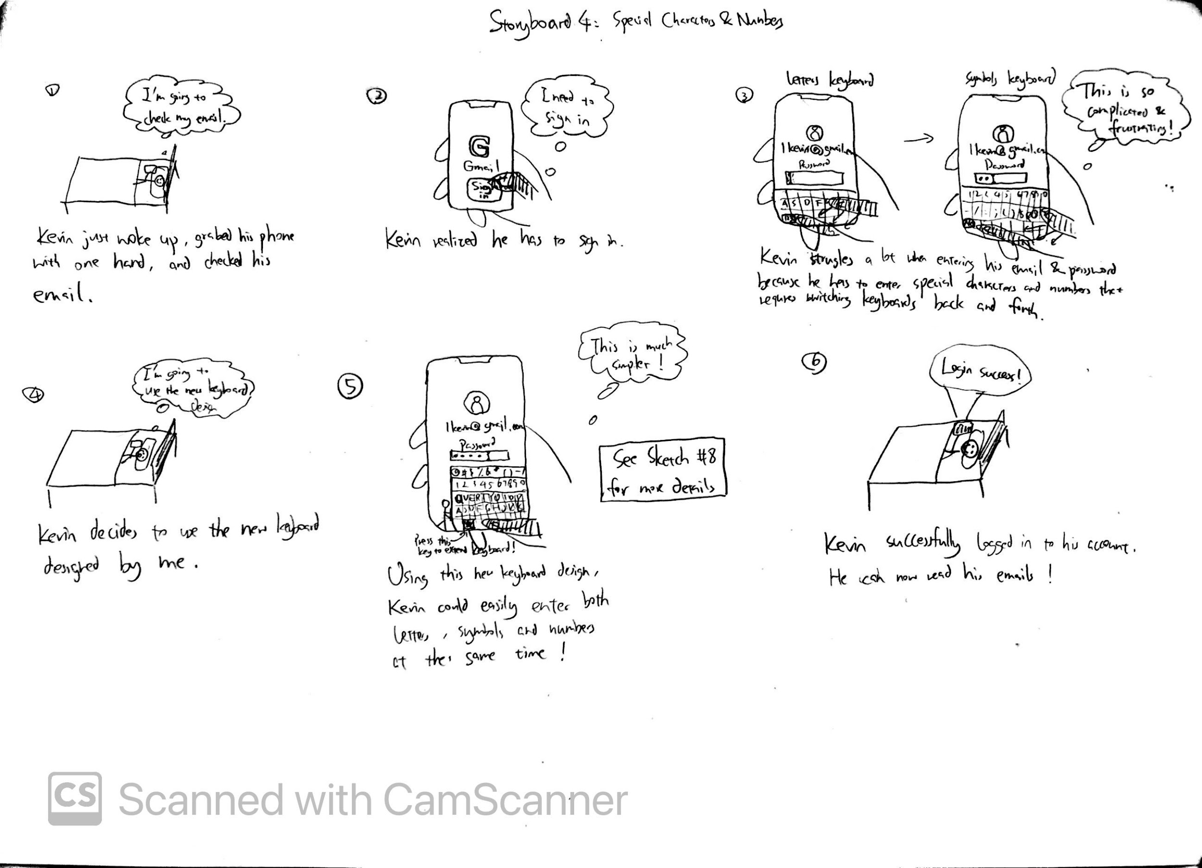

# Yichen’s Features

Quick switch function key that can switch among different keyboards (e.g. languages)

Details: When switching between traditional language keyboards, people often finds it difficult to control it with one hand, so I designed a quick-switch button. The key sits atop several existing alphanumeric keys, making it easy to reach with one hand. When you long-press, the quick switch will show up. The left half of this button is the shortcut key for the emoji keyboard, and the right half is the shortcut key for switching between language keyboards.

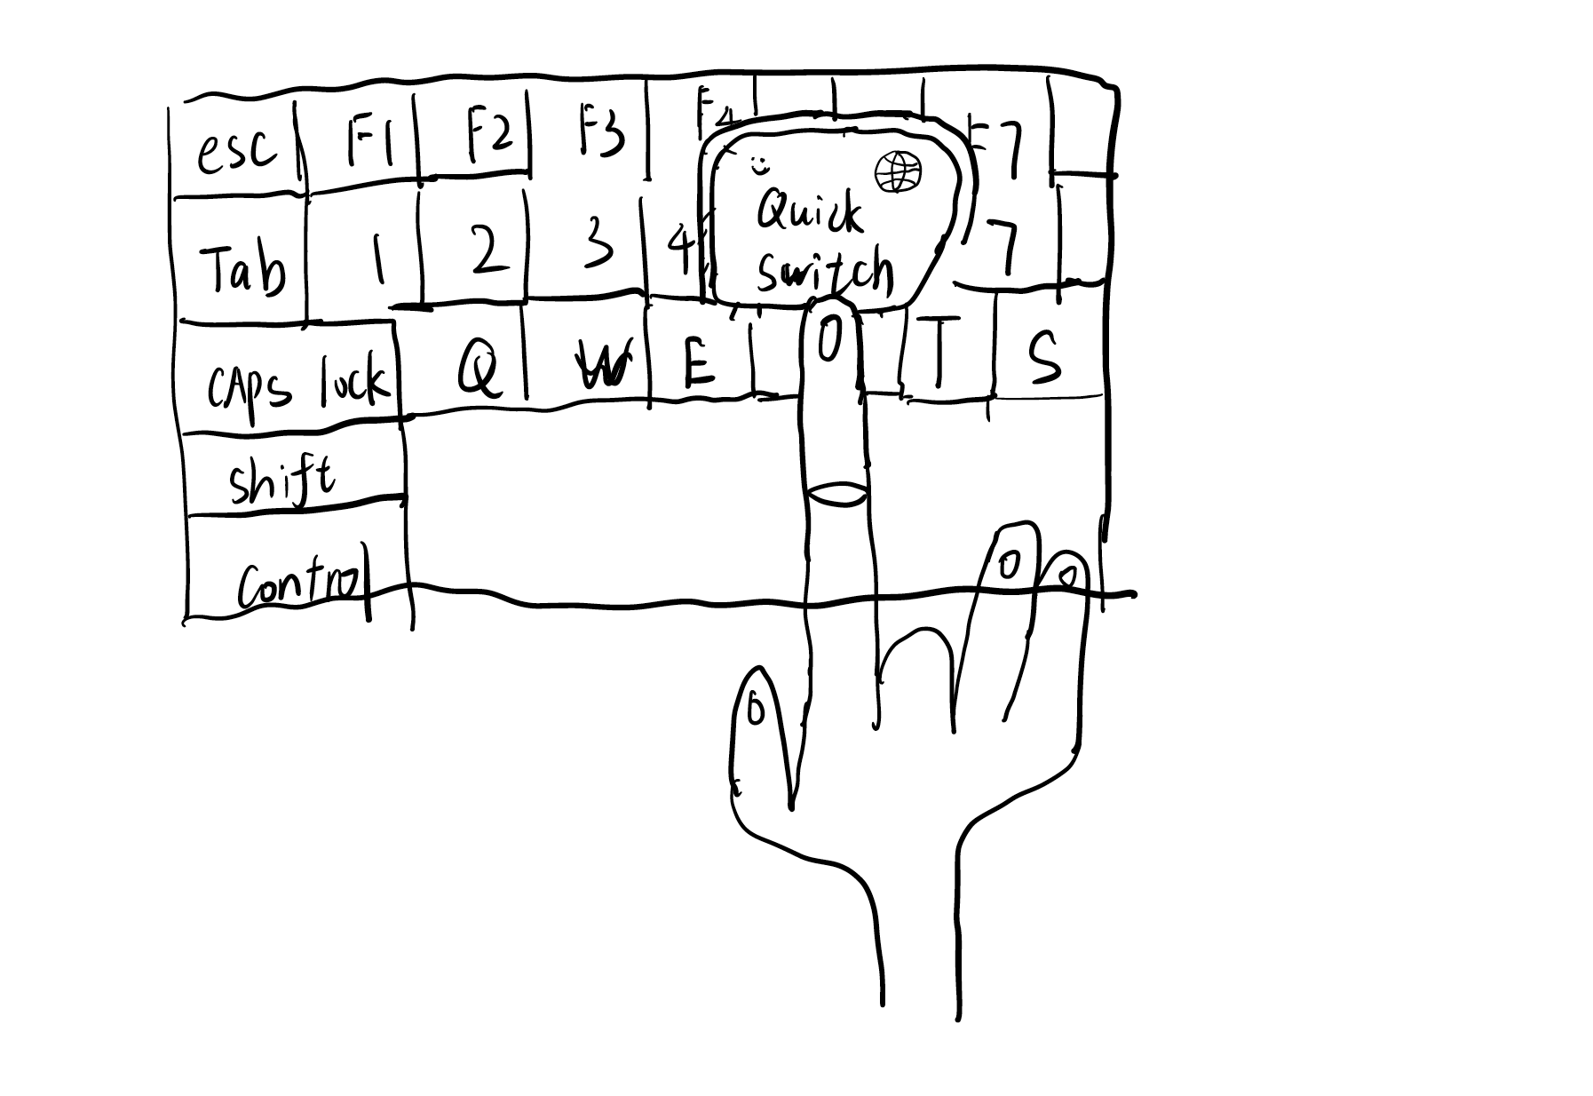

2. One-handed mode that allow users to type in one hand easily

Details:I designed a one-handed operation mode to allow people to easily type with one hand. When using this one-handed operation mode for the first time, you need to manually turn on the one-handed keyboard in Settings-Convenient Mode. After turning on this action, the keyboard will automatically switch to one-handed mode. Unlike ordinary fixed keyboards, the keyboard can slide left and right in one-handed mode. You can easily slide the keyboard with your thumb and use other fingers for one-handed typing. This design can solve trouble of often having to switch hand postures to touch different buttons.

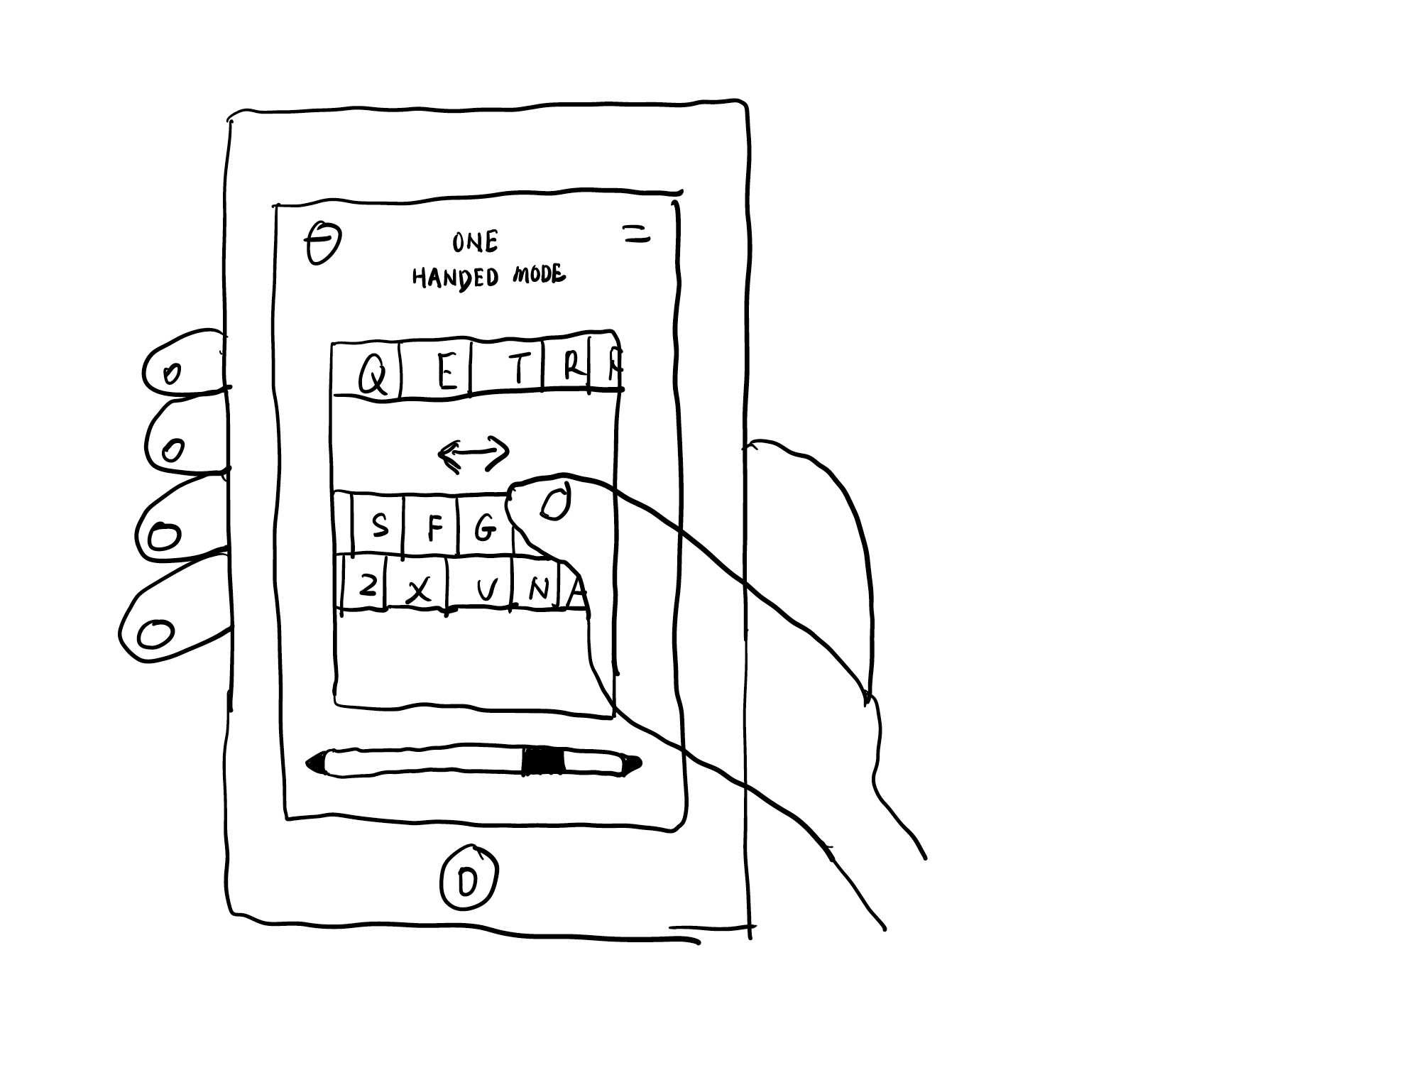

Storyboards:

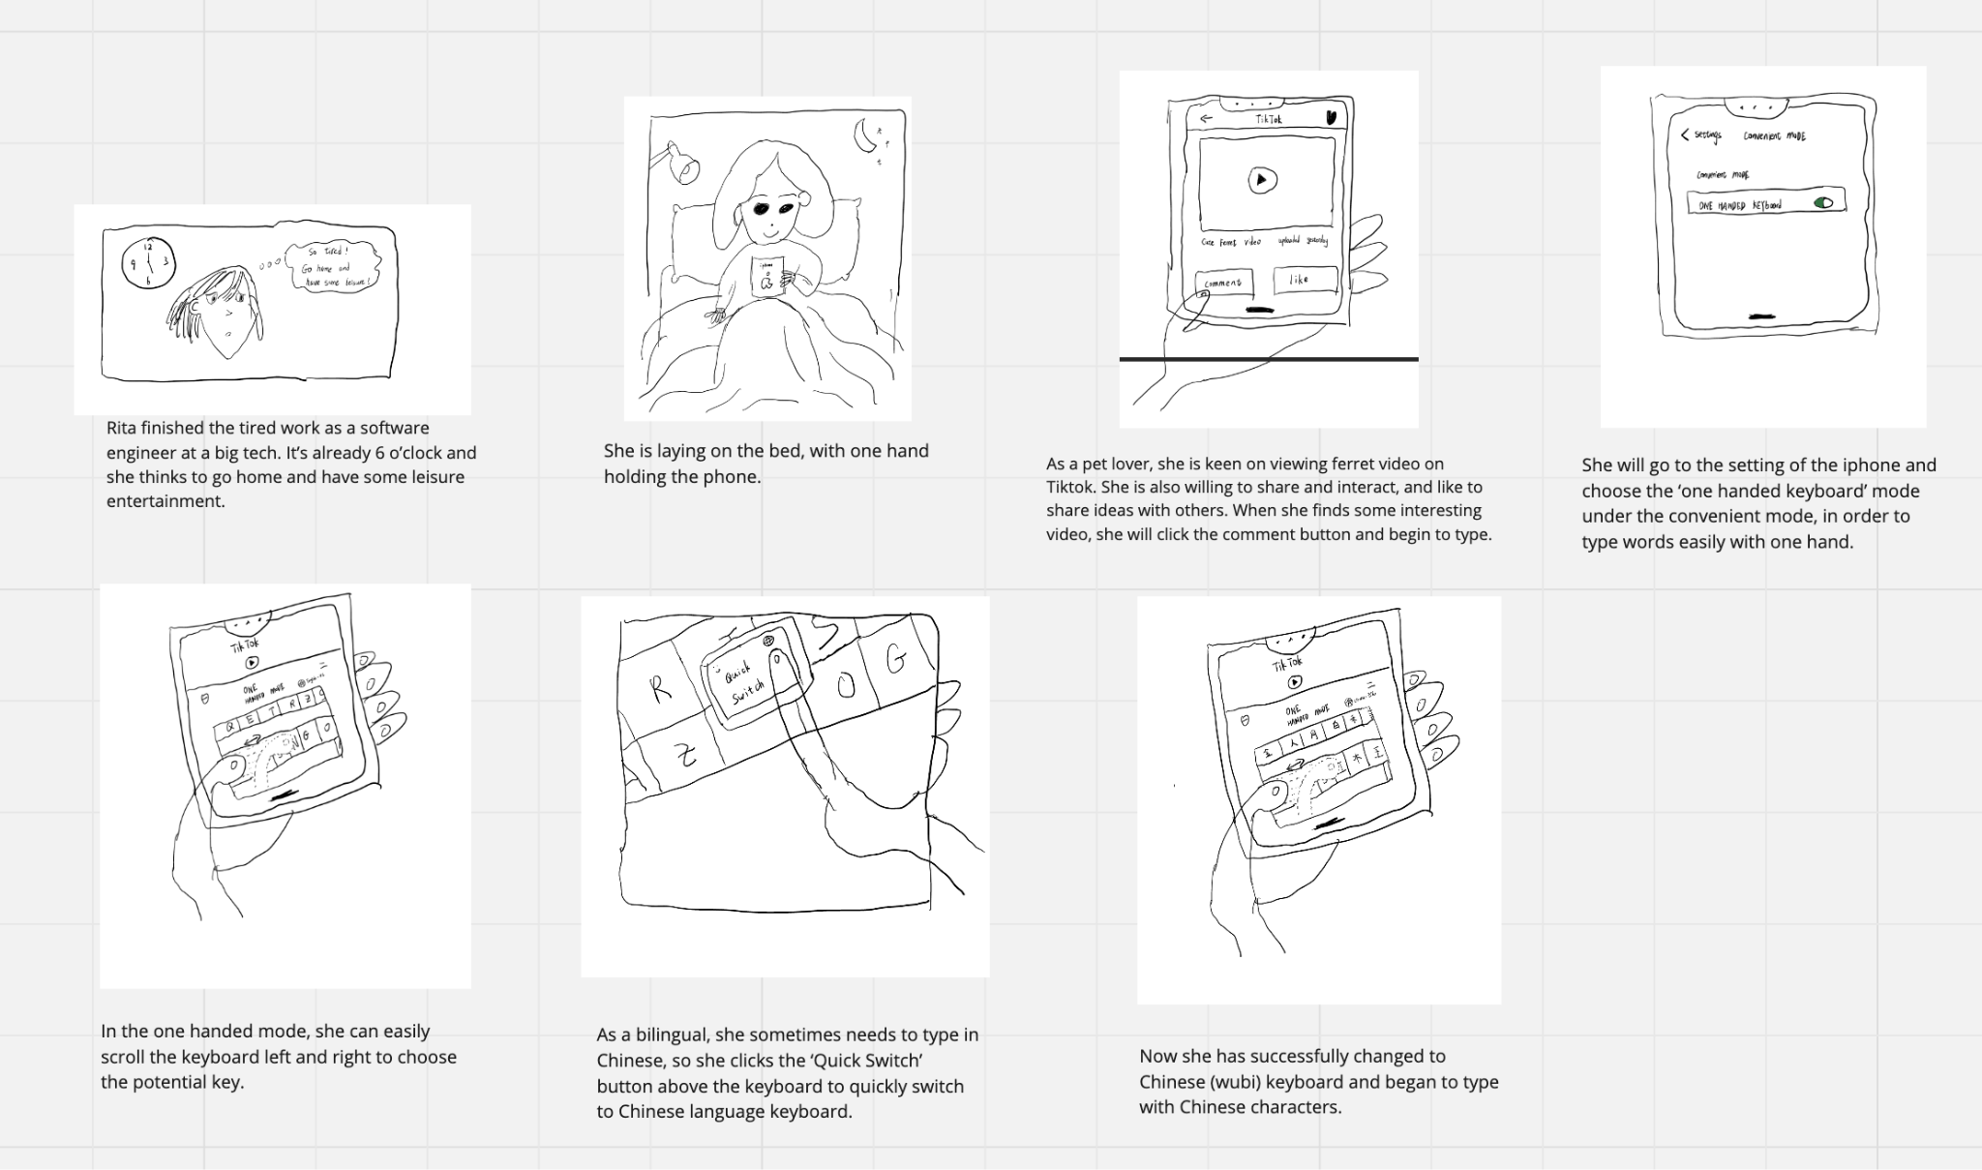

# 

# 

# 

# 

# 

# Isaac’s Features

* Predictive key enlargement.
  + A ML model will analyze the current app that the user is using, the context, the text/sentence content, and current word that the user is typing.
  + The ML model will generate predictions of the next letter that the user is going to press.
    - Franklin: Not sure if key prediction is helpful. There seems to be too many possibilities (that is to assume if it is learnable in the first place)
  + Those prediction keys will be enlarged. Larger than the other keys.
    - Franklin: this feature could be counter-productive if it predicts a false positive, making it even harder to input the keys because of the visual change.
    - Jerry: This is actually a very interesting idea. It helps address User Requirement 4, since it ideally will allow the user to comfortably reach the keys they want to enter. There might be too many possibilities initially (after the user only typed a 2 or 3 letters), but after a certain threshold of letters are entered, the probability of correctly predicting the letters the user is about to enter and the correspondingly enlarged keys will be more accurate. This feature can be more helpful to help predict non-alphabetical keys (like punctuations, special characters, and emojis), and display their keys on the top of the keyboard or something.

